**AWS and Big Data (MSDS 204)**

1. **Create an EC2 instance and connect it to create a text file in a new directory using commands.**

**Step 1: Open EC2 and click on launch instance**

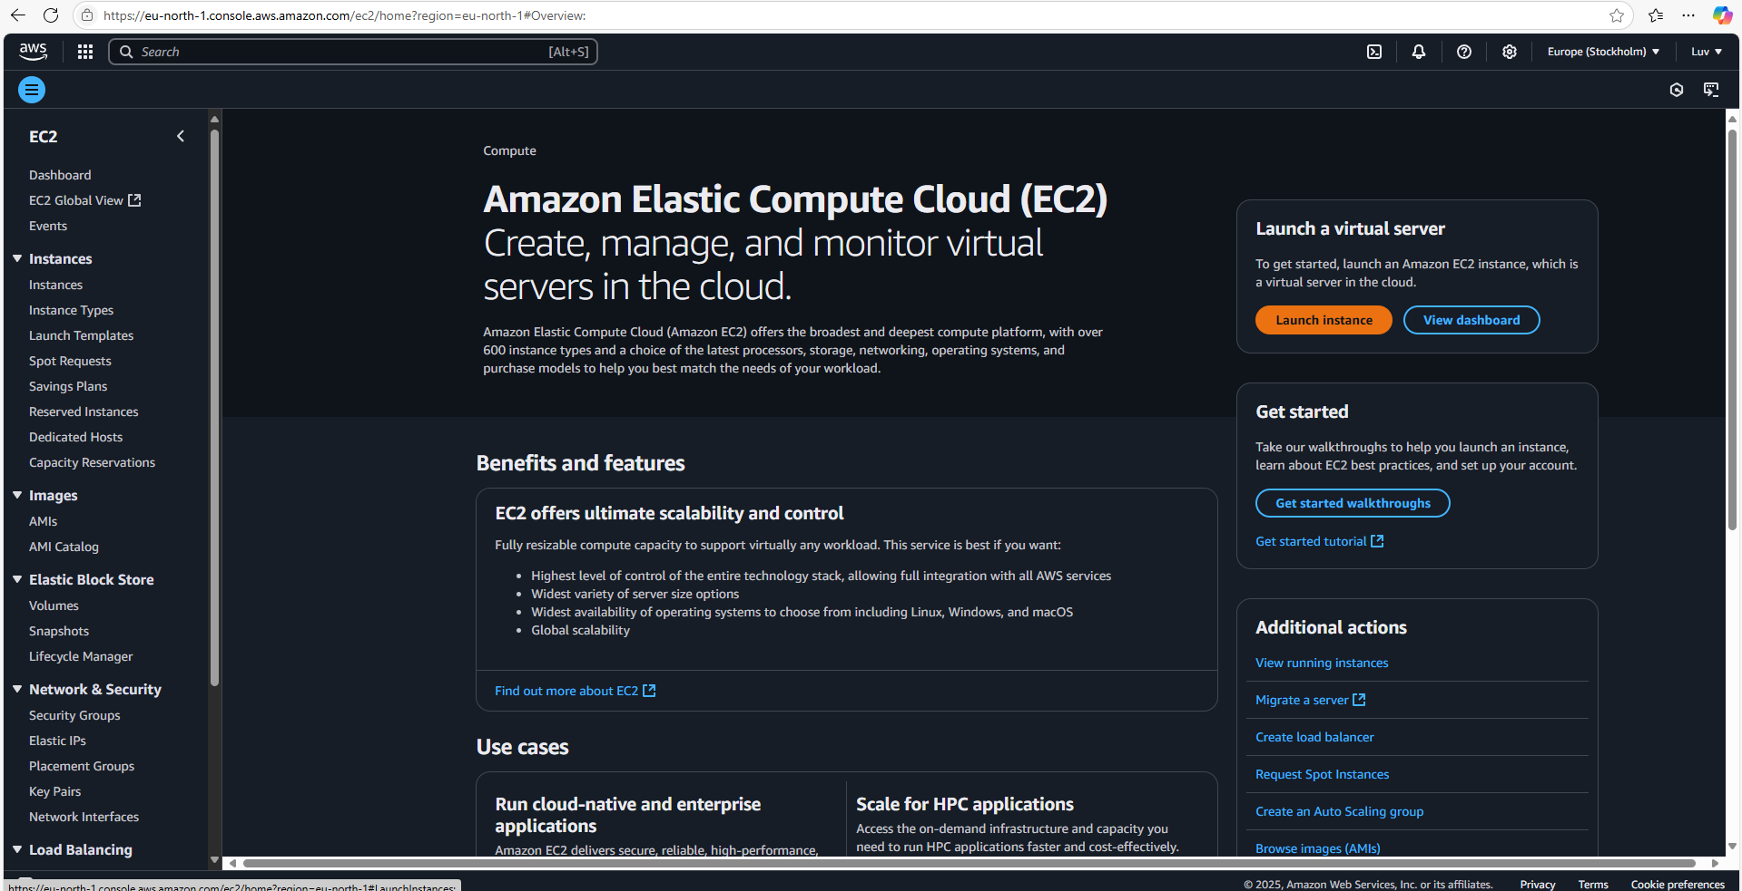

**Step 2: Enter details to create an instance**

1.Give instance a name

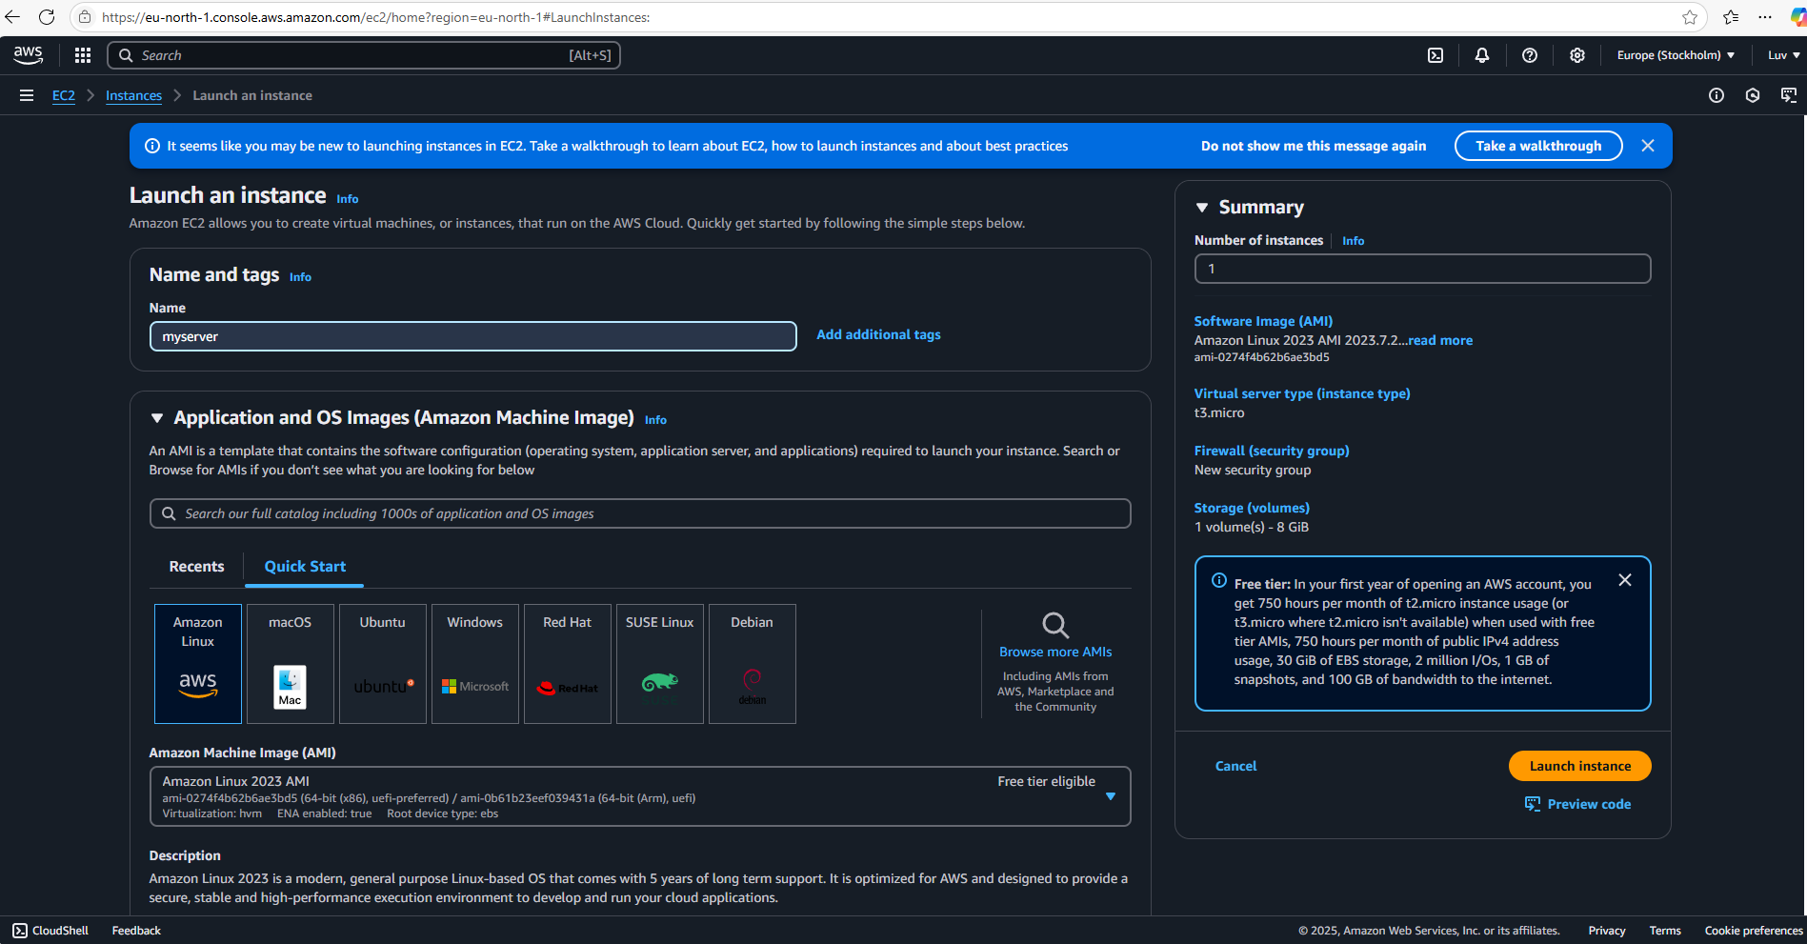

2.Create new Key Pair, rest all settings at default, click on launch instance.

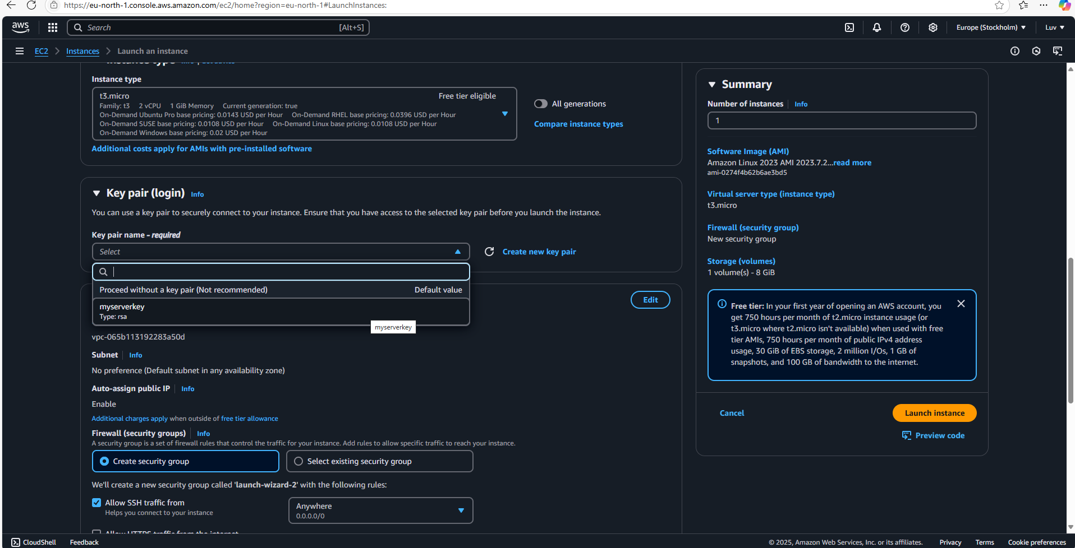

**Step 3: Instance will be created in few minutes. After that connect to that instance.** 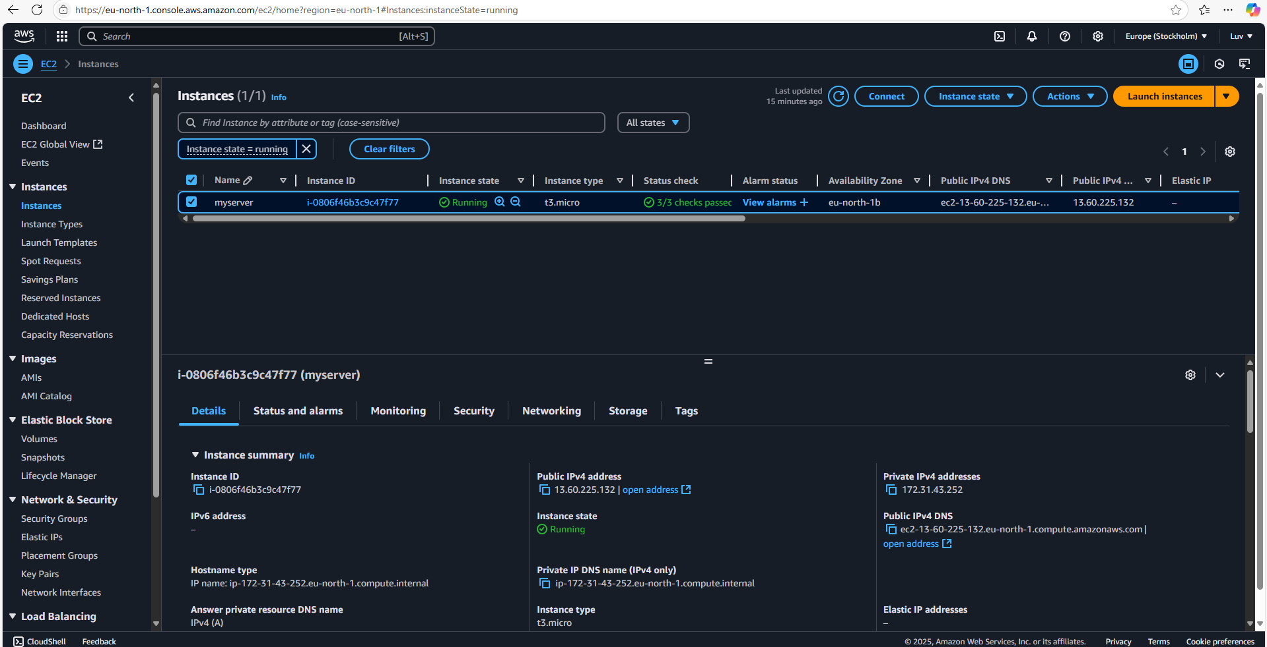

**Step 4: create a text file in a new directory using commands**

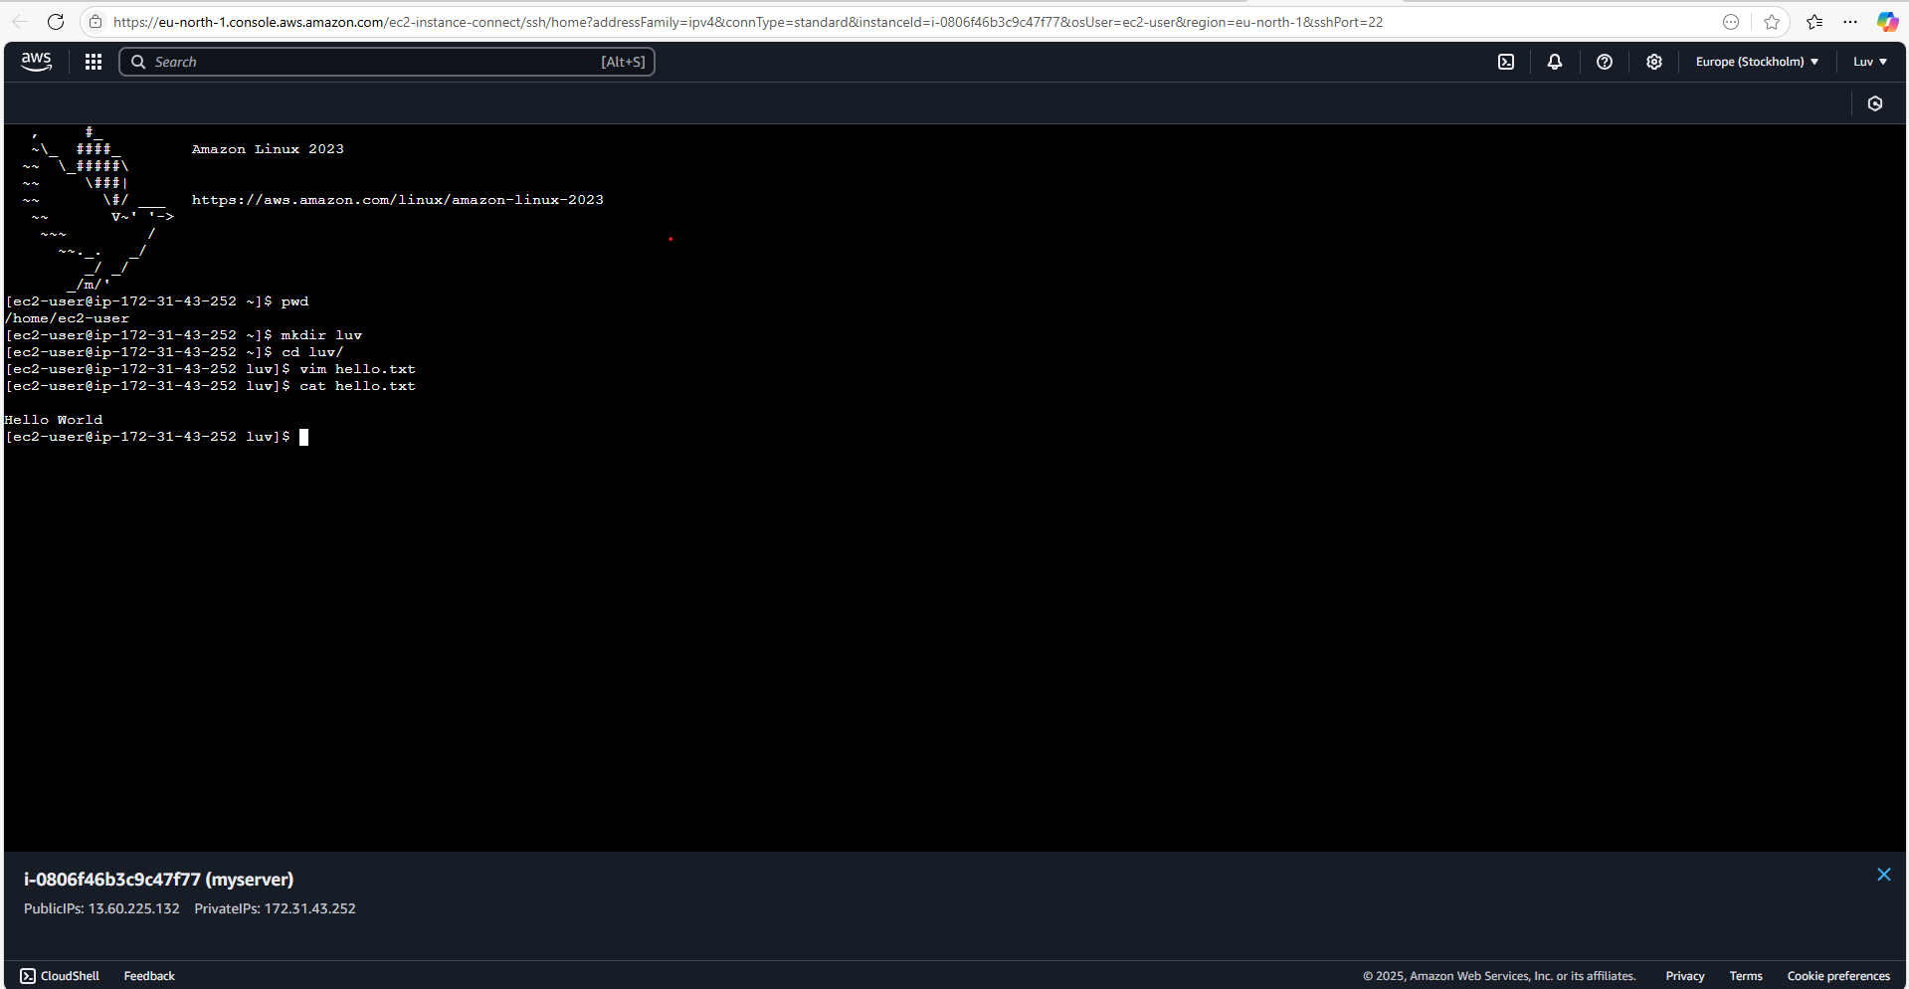

1. **Create a bucket in S3 and upload any file to make it public through URL**

**Step 1: Open S3 and click on CREATE BUCKET.**

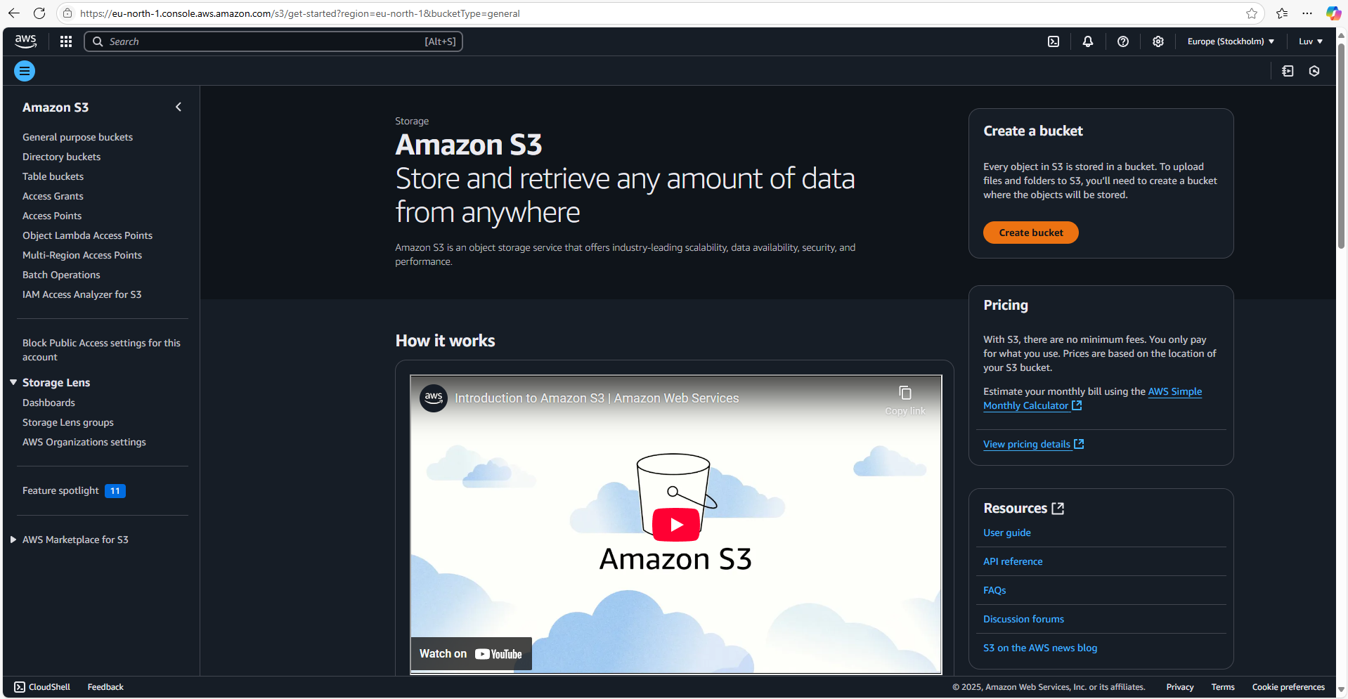

**Step 2: Set a unique bucket name.**

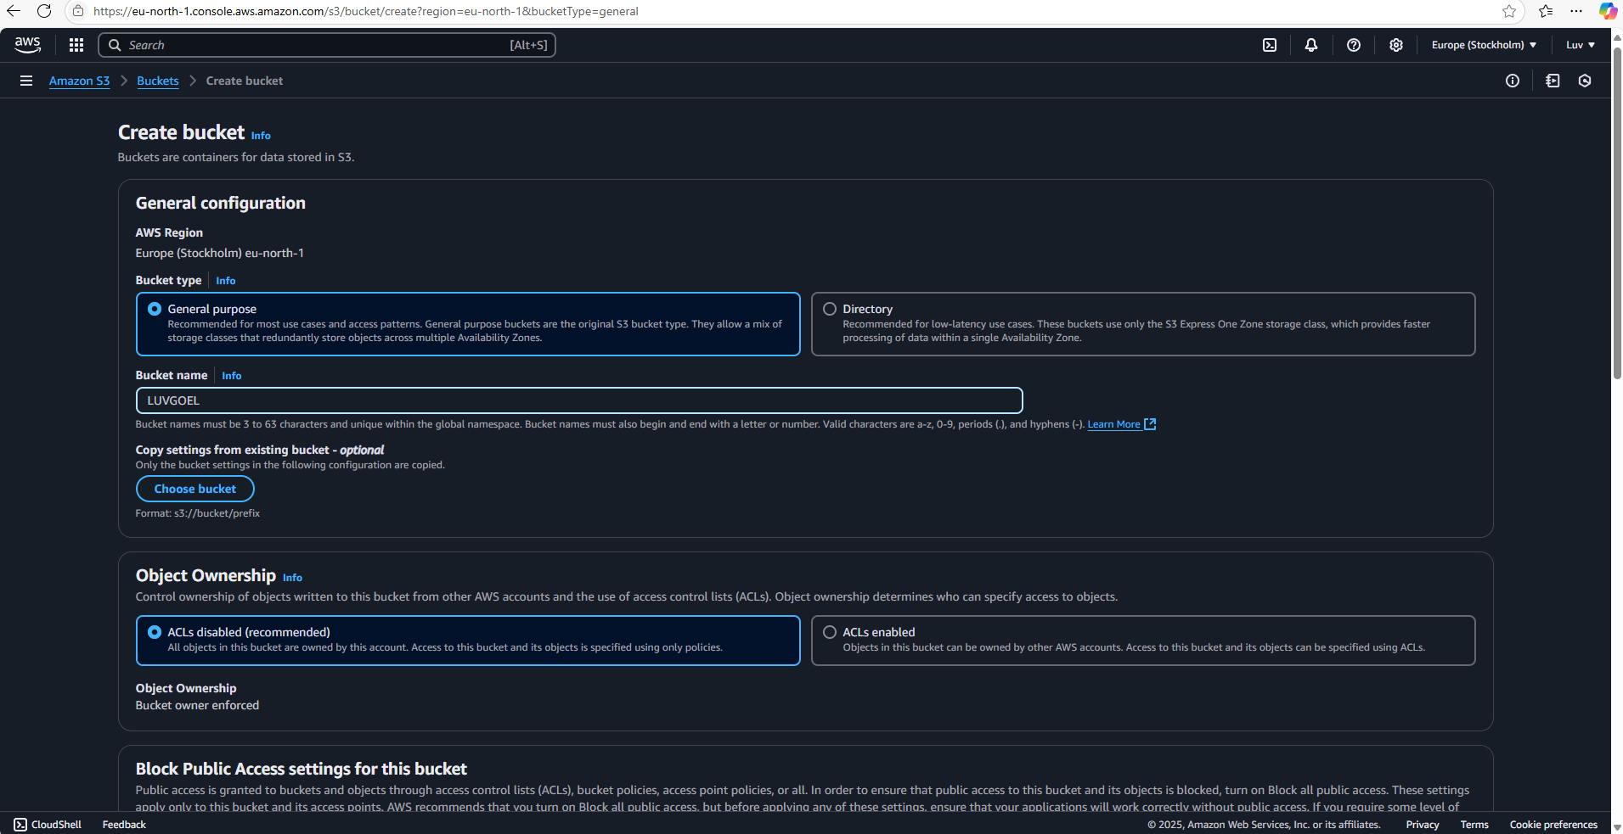

**Step 3: Uncheck the BLOCK PUBLIC ACCESS and then click on CREATE BUCKET.**

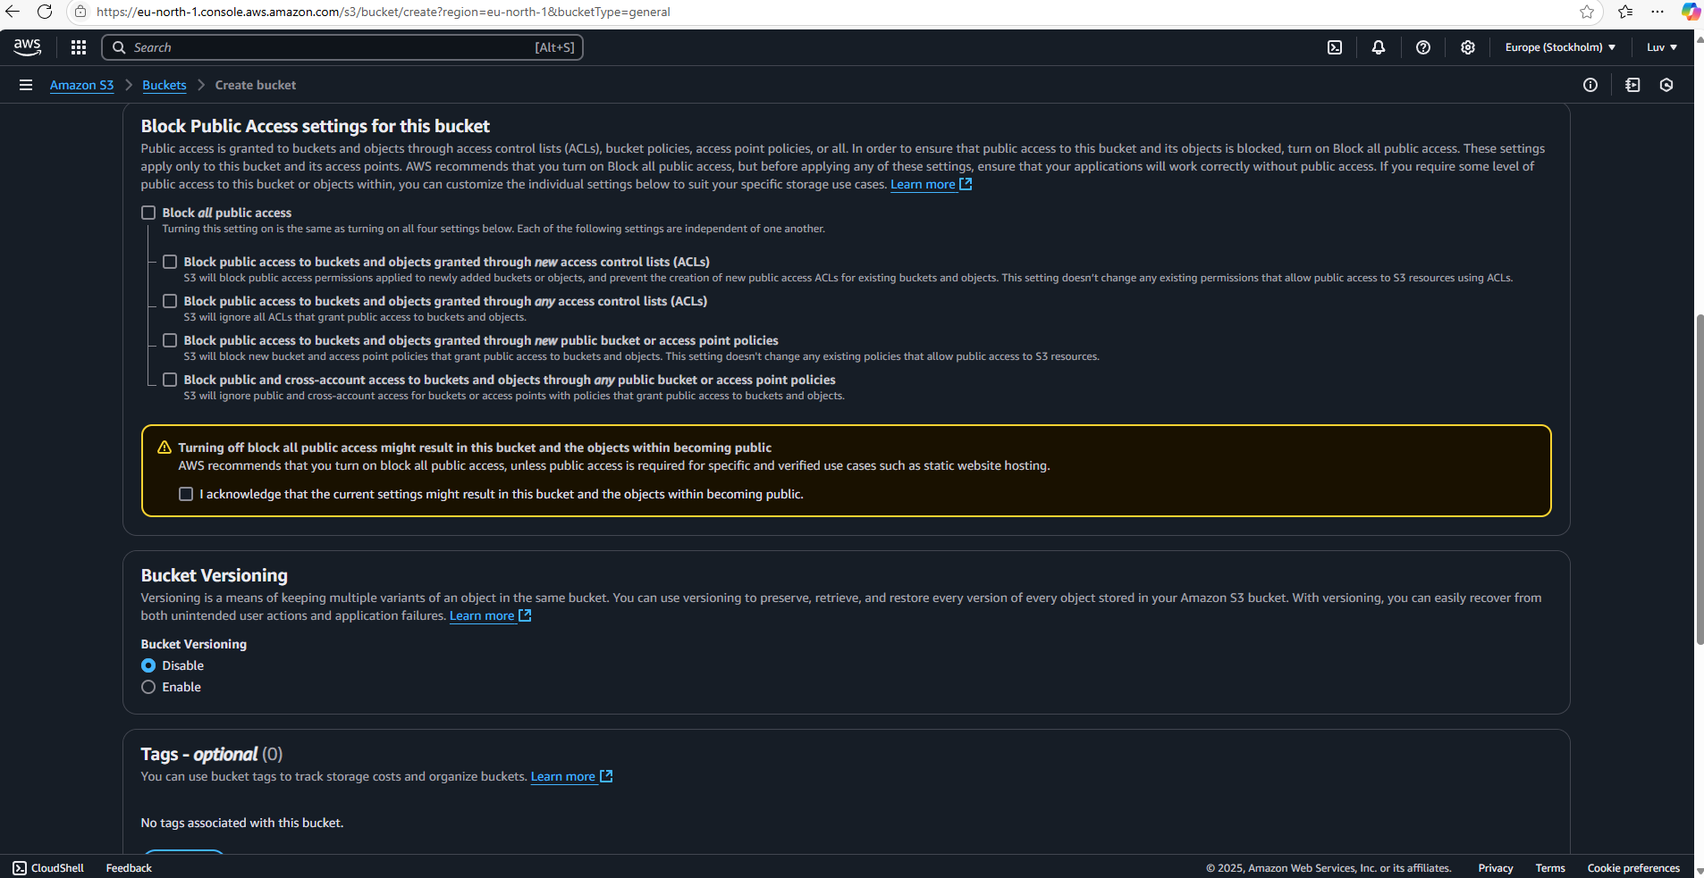

**Step 4: Upload an image in your bucket**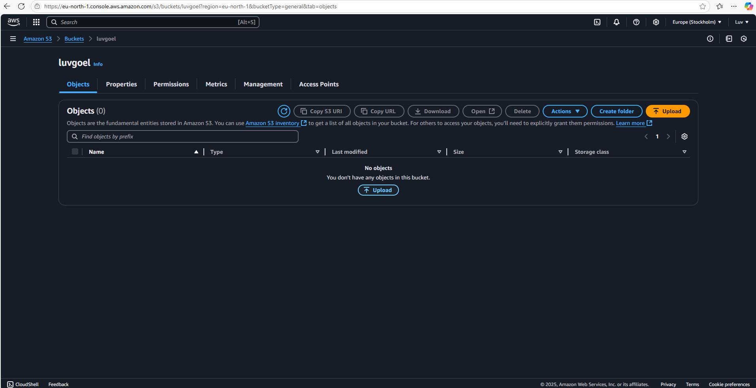

**Step 5: To make it public go to BUCKET>PERMISSIONS>** **BUCKET POLICY** **and GENERATE NEW POLICY** 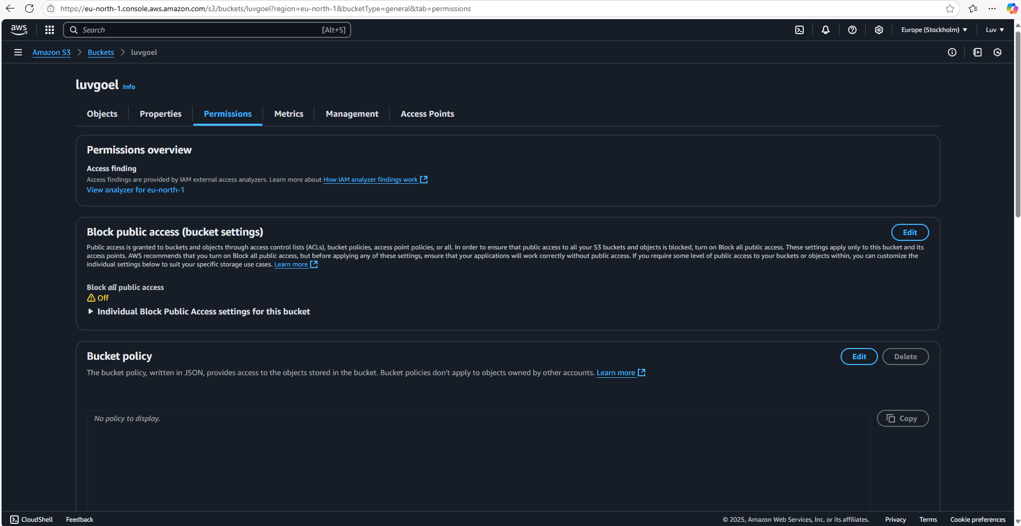

**Step 6: Generate policy with same settings.**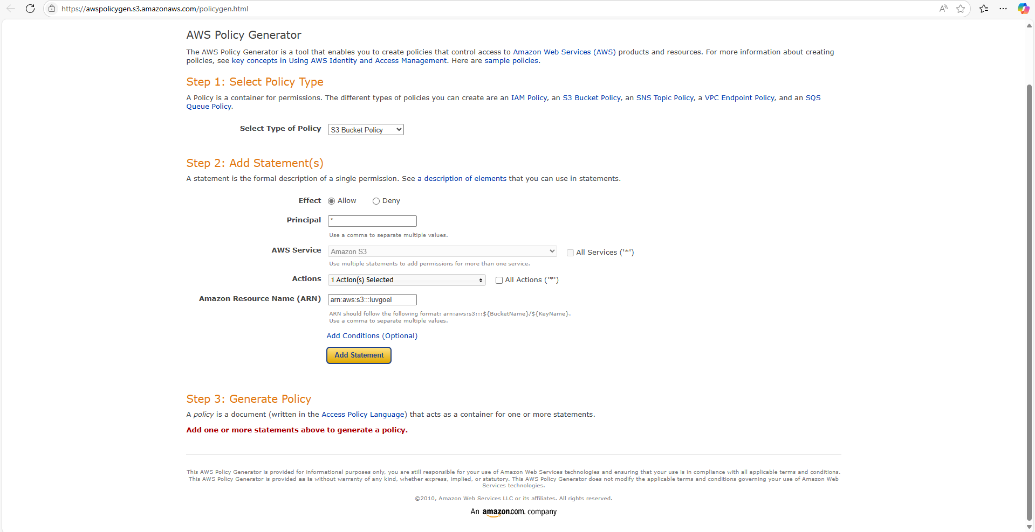

**Step 7: Copy generated policy to the bucket policy and save changes.**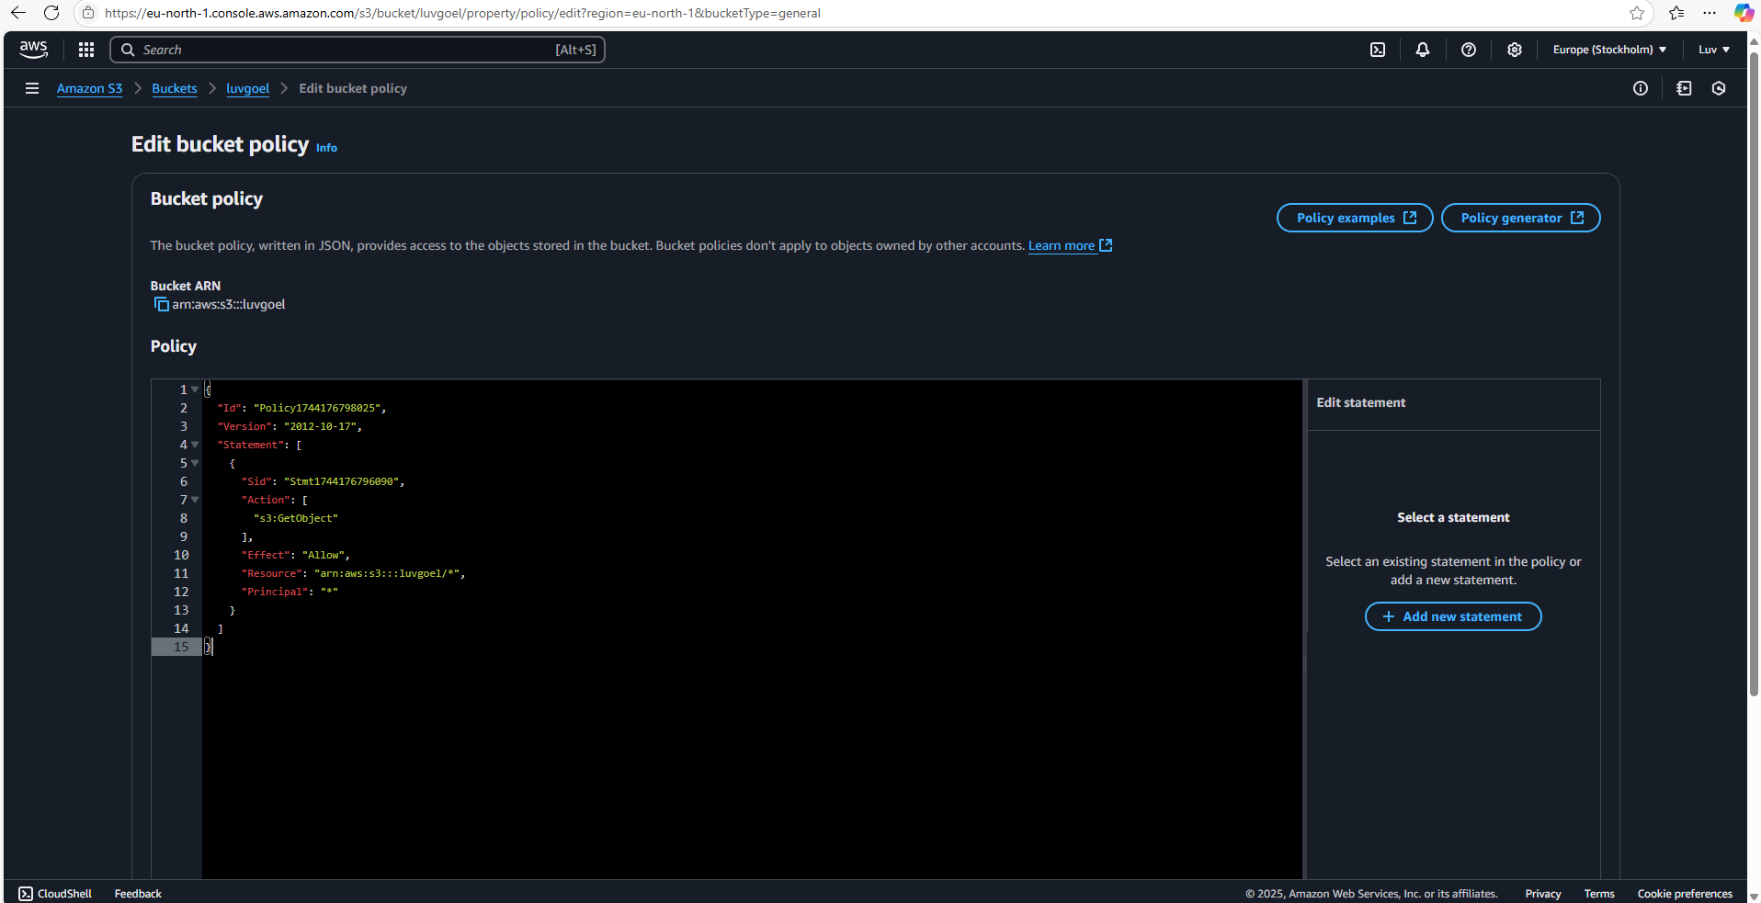

**Uploaded file is now public through URL.**

